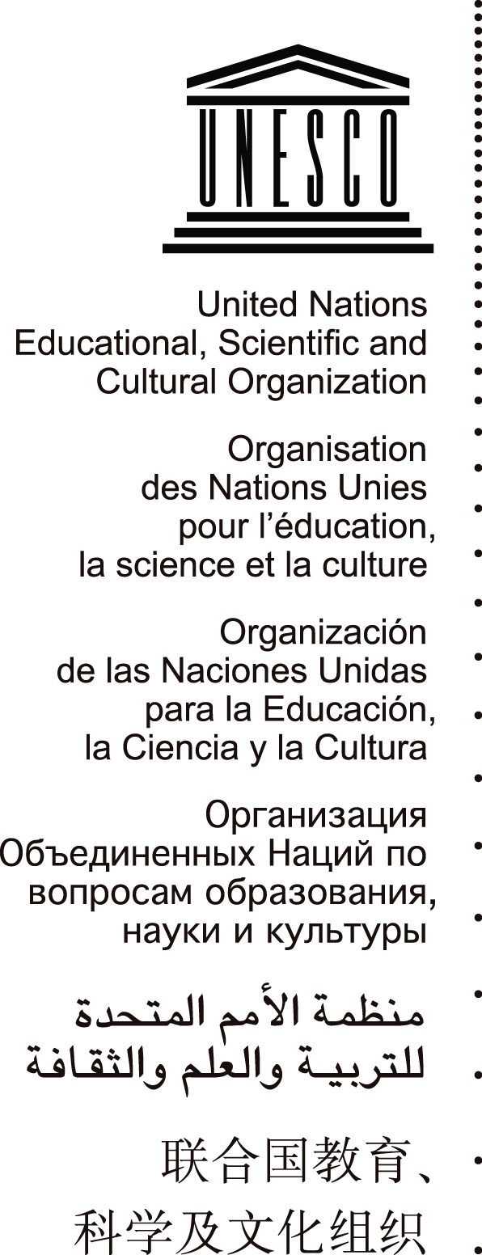 | JOURNALISM ETHICS AND SELF-REGULATION IN EUROPE:  NEW MEDIA, OLD DILEMMAS  27 January 2011  UNESCO, Paris, Room IV

PROGRAMME

Thursday 27 January 2011

9.30-10:00 a.m. Opening Session

Welcome Speech by Jānis Kārkliņš, Assistant Director General for Communication and Information, UNESCO

Address by Jan Kleijssen, Director of Standard Setting in the Directorate General of Human Rights and Legal Affairs of the Council of Europe

Address by Andris Kesteris, Principal Adviser - Civil Society and Inter-institutional Relations, European Commission

Address by William Horsley, Media Freedom Representative, Association of European Journalists

10:00-11:00 a.m. Media Accountability in Europe

Dunja Mijatovic, OSCE Representative on Freedom of the Media

Helge Rønning, Professor, Department of Media and Communication, University of Oslo, Norway

Nikos Konstandaras, Managing Editor and English Edition’s Editor-in-chief, Kathimerini, Greece

Sándor Orbán, Director, South East European Network for Professionalization of Media (SEENPM)

Moderator: Barbara Thomass, Professor for International Comparison of Media Systems, Institute for Media Studies at Ruhr-University, Bochum, Germany

Q&A Session

11:00-11.30 a.m. Coffee Break

11.30 a.m.-12.30 p.m. Internet, privacy, security
and professional standards

William Gore, Public Affairs Director, Press Complaints Commission, United Kingdom

Gordana Vilović, Associate Professor, Faculty of Political Science – Journalism Department, Zagreb University, Croatia

Agnès Callamard, Executive Director, ARTICLE 19, United Kingdom

Moderator: Jānis Kārkliņš, Assistant Director General for Communication and Information, UNESCO

Q&A Session

12.30- 2.30 p.m. Lunch Break

2.30-3.45 p.m. The Self-Regulation Experience

Ljiljana Zurovac, Executive Director, Press Council in Bosnia and Herzegovina

Yavuz Baydar, News Ombudsman, SABAH, Turkey

Jacob Mollerup, Listeners’ and Viewers’ Editor, Danmarks Radio, and current President of the Organization of News Ombudsmen (ONO)

Jeffrey Dvorkin, Professor at the Journalism Programme of the Centennial College/University of Toronto, Executive Director of the Organization of News Ombudsmen (ONO)

Moderator: Daphne Koene, Secretary, the Netherlands Press Council

Q&A Session

3.45-4.15 p.m. Coffee Break

4.15-5.15 p.m. Media Accountability in Emerging European
Democracies

Remzi Lani, Director, Albanian Media Institute

Yasemin İnceoğlu, Professor, Faculty of Communications, University of Galatasaray, Turkey

Ognian Zlatev, Managing Director, Media Development Center, Bulgaria

Biljana Tatomir, Deputy Director, Media Program, Open Society Foundation- London, United Kingdom

Moderator: Ioana Avadani, Executive Director, Center for Independent Journalism, Romania

Q&A Session

5.15- 5.30 p.m. Closing Session

Jānis Kārkliņš, Assistant Director General for Communication and Information, UNESCO

18.00 p.m. Cocktail

